Lab Exercises Session 4: Simple Web Server
In this lab, you will learn the basics of socket programming for TCP connections in Python: how to create
a socket, bind it to a specific address and port, as well as send and receive a HTTP packet. You will also
learn some basics of HTTP header format.
You will develop a web server that handles one HTTP request at a time. Your web server should accept
and parse the HTTP request, get the requested file from the server’s file system, create an HTTP response
message consisting of the requested file preceded by header lines, and then send the response directly to
the client. If the requested file is not present in the server, the server should send an HTTP “404 Not
Found” message back to the client.

Basic Web Server
Objective: Implement a simple HTTP server handling one request.
Exercise 1: Implement a webserver to handle HTTP: You can use the Skeleton code provided
- Run the sever, connect it from local machine (browser)
- Connect the webserver from another machine (browser)
from socket import *
import sys
import time
import datetime
serverSocket = socket(AF_INET, SOCK_STREAM)
serverPort = 8080
serverSocket.bind(('', serverPort))
serverSocket.listen(1)
print("Server is ready to serve on port", serverPort)
while True:
print('Ready to serve...')
connectionSocket, addr = serverSocket.accept()
try:
message = connectionSocket.recv(1024)
response = "Hello"
connectionSocket.send("HTTP/1.1 200 OK\r\nContent-Type: text/html\r\n\r\n".encode())
for i in range(0, len(response)):
connectionSocket.send(response[i].encode())
connectionSocket.send("\r\n".encode())
connectionSocket.close()

except IOError:
response = "HTTP/1.1 404 Not Found\r\nContent-Type: text/html\r\n\r\n<html><body><h1>404 Not Found</h1></body></html>"
connectionSocket.send(response.encode())

connectionSocket.close()

serverSocket.close()
sys.exit()
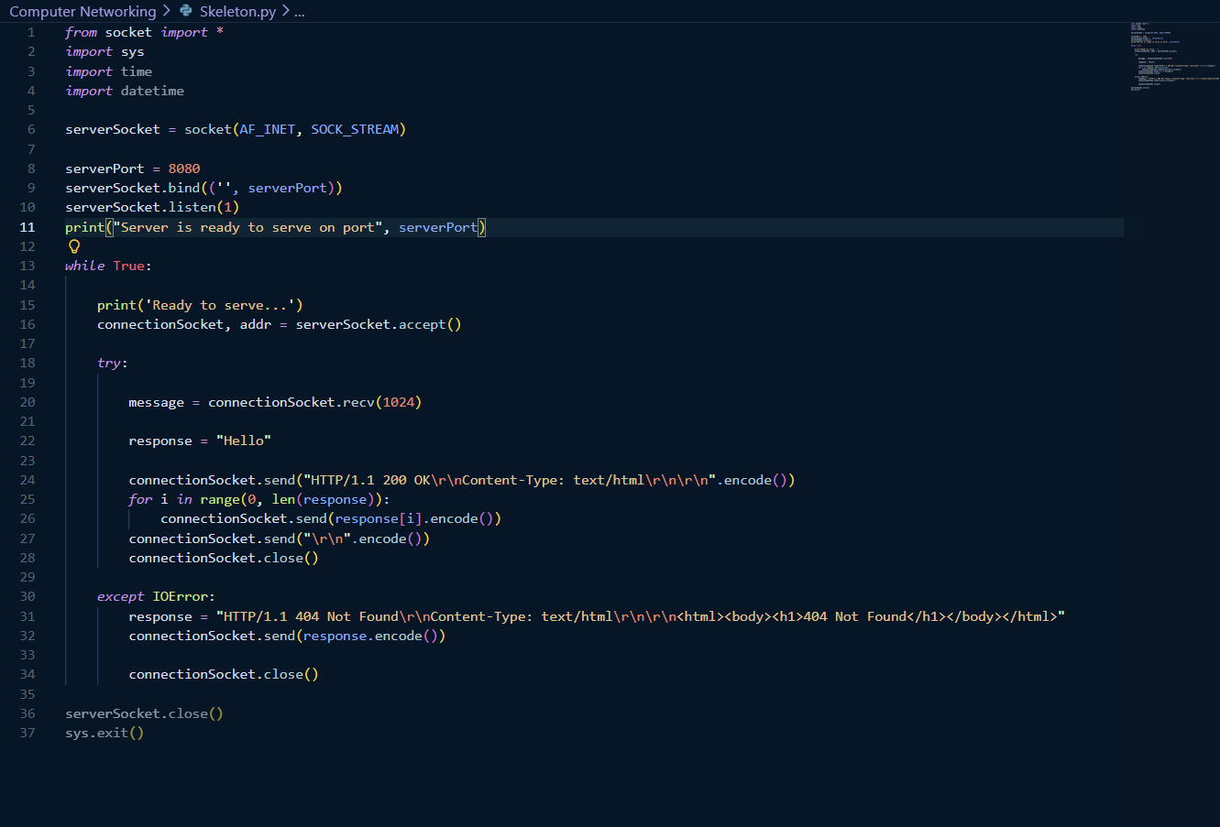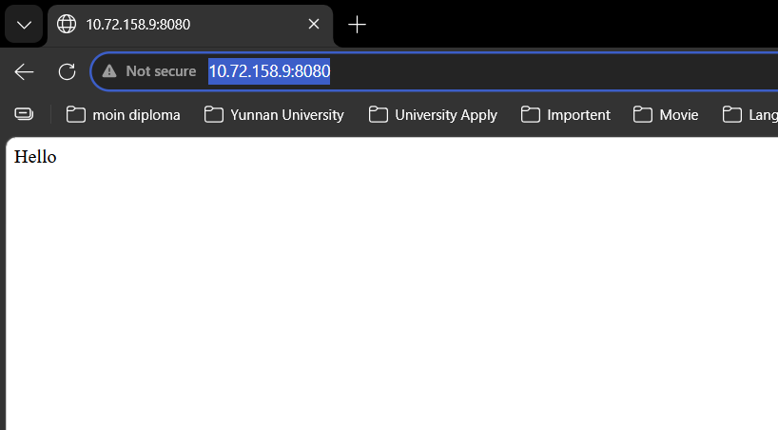
Exercise 2: 404 Error Handling
Modify the server to return 404 for missing files.
from socket import *
import sys
import time
import datetime

serverSocket = socket(AF_INET, SOCK_STREAM)

serverPort = 1200
serverSocket.bind(('', serverPort))
serverSocket.listen(1)
print("Server is ready to serve on port", serverPort)

while True:

print('Ready to serve...')
connectionSocket, addr = serverSocket.accept()

try:

message = connectionSocket.recv(1024)
if not message:
continue

filename = message.split()[1]
print(f"Requested file: {filename}")

log_entry = f"{datetime.datetime.now()} - Client {addr[0]} requested {filename}\n"
print(log_entry.strip())

f = open(filename[1:], 'r')
outputdata = f.read()
f.close()

connectionSocket.send("HTTP/1.1 200 OK\r\nContent-Type: text/html\r\n\r\n".encode())

for i in range(0, len(outputdata)):
connectionSocket.send(outputdata[i].encode())
connectionSocket.send("\r\n".encode())
connectionSocket.close()

except IOError:
response = "HTTP/1.1 404 Not Found\r\nContent-Type: text/html\r\n\r\n<html><body><h1>404 Not Found</h1></body></html>"
connectionSocket.send(response.encode())

connectionSocket.close()

serverSocket.close()
sys.exit()

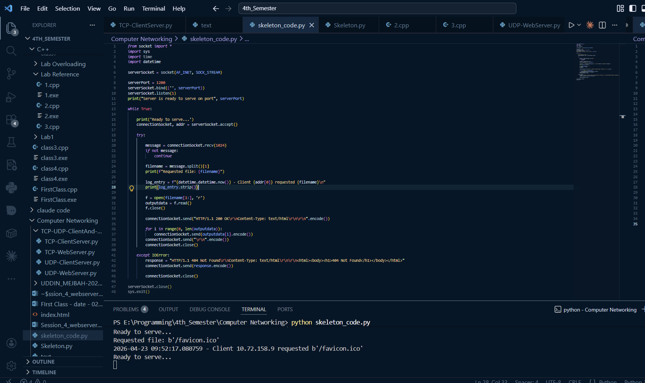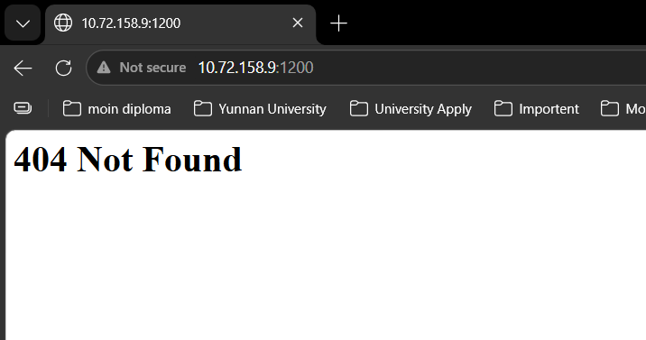

Exercise 3: Serve Different File Types
Extend server to support HTML, TXT, and JPG.
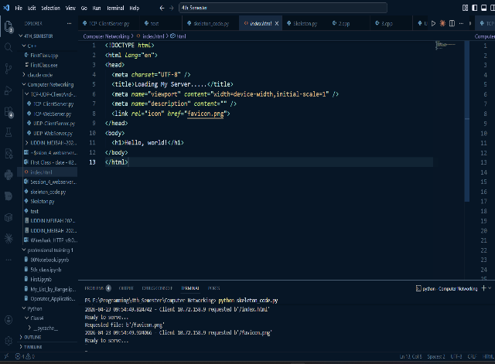

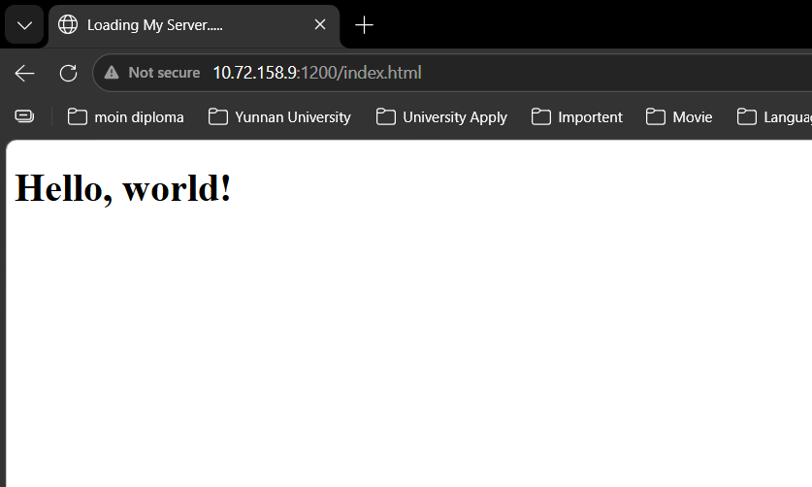
Server Code :
from socket import *
import sys
import time
import datetime

serverSocket = socket(AF_INET, SOCK_STREAM)

serverPort = 1200
serverSocket.bind(('', serverPort))
serverSocket.listen(1)
print("Server is ready to serve on port", serverPort)

while True:

print('Ready to serve...')
connectionSocket, addr = serverSocket.accept()

try:

message = connectionSocket.recv(1024)
if not message:
continue

filename = message.split()[1]
print(f"Requested file: {filename}")

log_entry = f"{datetime.datetime.now()} - Client {addr[0]} requested {filename}\n"
print(log_entry.strip())

f = open(filename[1:], 'r')
outputdata = f.read()
f.close()

connectionSocket.send("HTTP/1.1 200 OK\r\nContent-Type: text/html\r\n\r\n".encode())

for i in range(0, len(outputdata)):
connectionSocket.send(outputdata[i].encode())
connectionSocket.send("\r\n".encode())
connectionSocket.close()

except IOError:
response = "HTTP/1.1 404 Not Found\r\nContent-Type: text/html\r\n\r\n<html><body><h1>404 Not Found</h1></body></html>"
connectionSocket.send(response.encode())

connectionSocket.close()

serverSocket.close()
sys.exit()

Exercise 4: Logging Requests
Log client IP, requested file, and timestamp.
from socket import *
import sys
import datetime

serverSocket = socket(AF_INET, SOCK_STREAM)

serverPort = 1200
serverSocket.bind(('', serverPort))
serverSocket.listen(1)
print("Server is ready to serve on port", serverPort)

while True:
print('Ready to serve...')
connectionSocket, addr = serverSocket.accept()

try:
message = connectionSocket.recv(1024)
if not message:
continue

filename = message.split()[1]
print(f"Requested file: {filename}")

log_entry = f"{datetime.datetime.now()} - Client {addr[0]} requested {filename}\n"
print(log_entry.strip())

f = open(filename[1:], 'r')
outputdata = f.read()
f.close()

connectionSocket.send("HTTP/1.1 200 OK\r\nContent-Type: text/html\r\n\r\n".encode())

for i in range(len(outputdata)):
connectionSocket.send(outputdata[i].encode())
connectionSocket.send("\r\n".encode())

connectionSocket.close()

except IOError:
response = "HTTP/1.1 404 Not Found\r\nContent-Type: text/html\r\n\r\n<html><body><h1>404 Not Found</h1></body></html>"
connectionSocket.send(response.encode())
connectionSocket.close()

serverSocket.close()
sys.exit()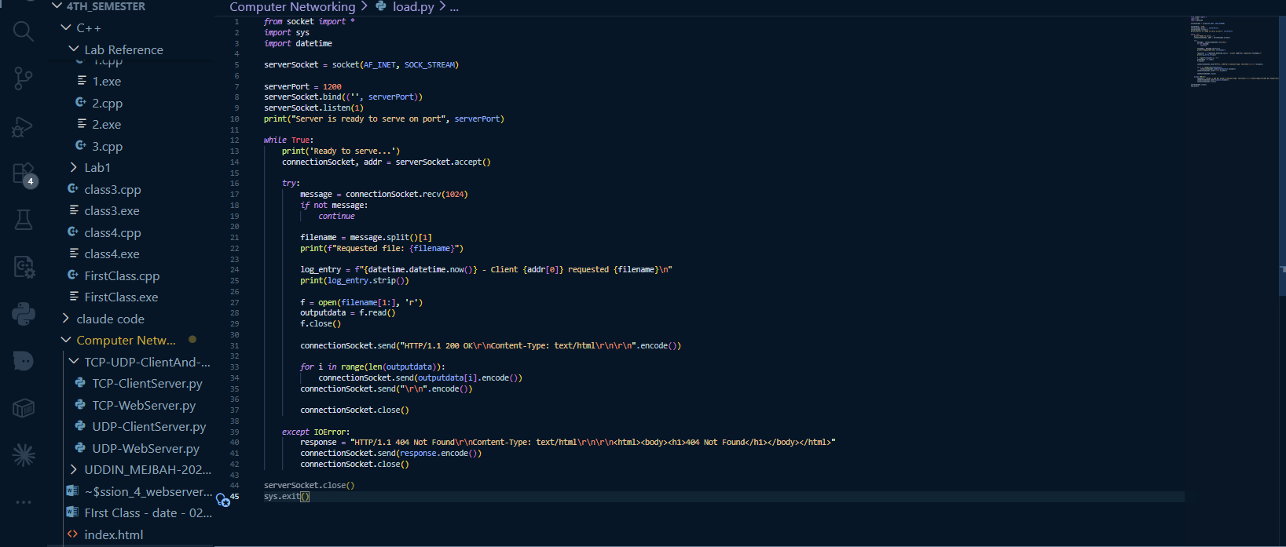
Exercise 5: Static HTML Response
Return a hardcoded HTML page.
from socket import *
import sys
import datetime

serverSocket = socket(AF_INET, SOCK_STREAM)

serverPort = 1200
serverSocket.bind(('', serverPort))
serverSocket.listen(1)
print("Server is ready to serve on port", serverPort)

static_html = """
<html>
<head><title>Static Page</title></head>
<body>
<h1>Welcome to My Web Server</h1>
<p>This is a static HTML page served by the server.</p>
</body>
</html>
"""

while True:
print('Ready to serve...')
connectionSocket, addr = serverSocket.accept()

try:
message = connectionSocket.recv(1024)
if not message:
continue

filename = message.split()[1]
print(f"Requested file: {filename}")

log_entry = f"{datetime.datetime.now()} - Client {addr[0]} requested {filename}\n"
print(log_entry.strip())

if filename == b'/' or filename == b'/index.html':
response = "HTTP/1.1 200 OK\r\nContent-Type: text/html\r\n\r\n" + static_html
connectionSocket.send(response.encode())
else:
f = open(filename[1:], 'r')
outputdata = f.read()
f.close()

connectionSocket.send("HTTP/1.1 200 OK\r\nContent-Type: text/html\r\n\r\n".encode())

for i in range(len(outputdata)):
connectionSocket.send(outputdata[i].encode())
connectionSocket.send("\r\n".encode())

connectionSocket.close()

except IOError:
response = "HTTP/1.1 404 Not Found\r\nContent-Type: text/html\r\n\r\n<html><body><h1>404 Not Found</h1></body></html>"
connectionSocket.send(response.encode())
connectionSocket.close()

serverSocket.close()
sys.exit()
Exercise 6: Add Delay
Simulate slow server using sleep.
from socket import *
import sys
import datetime
import time

serverSocket = socket(AF_INET, SOCK_STREAM)

serverPort = 1200
serverSocket.bind(('', serverPort))
serverSocket.listen(1)
print("Server is ready to serve on port", serverPort)

static_html = """
<html>
<head><title>Static Page</title></head>
<body>
<h1>Welcome to My Web Server</h1>
<p>This is a static HTML page served by the server.</p>
</body>
</html>
"""

while True:
print('Ready to serve...')
connectionSocket, addr = serverSocket.accept()

try:
message = connectionSocket.recv(1024)
if not message:
continue

filename = message.split()[1]
print(f"Requested file: {filename}")

log_entry = f"{datetime.datetime.now()} - Client {addr[0]} requested {filename}\n"
print(log_entry.strip())

time.sleep(2)

if filename == b'/' or filename == b'/index.html':
response = "HTTP/1.1 200 OK\r\nContent-Type: text/html\r\n\r\n" + static_html
connectionSocket.send(response.encode())
else:
f = open(filename[1:], 'r')
outputdata = f.read()
f.close()

connectionSocket.send("HTTP/1.1 200 OK\r\nContent-Type: text/html\r\n\r\n".encode())

for i in range(len(outputdata)):
connectionSocket.send(outputdata[i].encode())
connectionSocket.send("\r\n".encode())

connectionSocket.close()

except IOError:
response = "HTTP/1.1 404 Not Found\r\nContent-Type: text/html\r\n\r\n<html><body><h1>404 Not Found</h1></body></html>"
connectionSocket.send(response.encode())
connectionSocket.close()

serverSocket.close()
sys.exit()
Exercise 7 (Optional): Concurrent Server
Implement multi-threaded server.

Code
Below you will find the skeleton code for the Web server. You are to complete the skeleton code. The
places where you need to fill in code are marked with #Fill in start and #Fill in end. Each place
may require one or more lines of code.

Skeleton Python Code for the Web Server
#import socket module
from socket import *
import sys # In order to terminate the program
serverSocket = socket(AF_INET, SOCK_STREAM)
#Prepare a sever socket
#Fill in start
#Fill in end
while True:
#Establish the connection
print('Ready to serve...')
connectionSocket, addr = #Fill in start #Fill in end
try:
message = #Fill in start #Fill in end
filename = message.split()[1]
f = open(filename[1:])
outputdata = #Fill in start #Fill in end
#Send one HTTP header line into socket
#Fill in start
#Fill in end
#Send the content of the requested file to the client
for i in range(0, len(outputdata)):
connectionSocket.send(outputdata[i].encode())
connectionSocket.send("\r\n".encode())
connectionSocket.close()
except IOError:
#Send response message for file not found
#Fill in start#Fill in end
#Close client socket
#Fill in start
#Fill in end
serverSocket.close()
sys.exit()#Terminate the program after sending the corresponding data

Running the Server
Put an HTML file (e.g., HelloWorld.html) in the same directory that the server is in. Run the server
program. Determine the IP address of the host that is running the server (e.g., 128.238.251.26). From another host, open a browser and provide the corresponding URL. For example:
http://128.238.251.26:6789/HelloWorld.html
‘HelloWorld.html’ is the name of the file you placed in the server directory. Note also the use of the port
number after the colon. You need to replace this port number with whatever port you have used in the
server code. In the above example, we have used the port number 6789. The browser should then display
the contents of HelloWorld.html. If you omit ":6789", the browser will assume port 80 and you will get
the web page from the server only if your server is listening at port 80.
Then try to get a file that is not present at the server. You should get a “404 Not Found” message.

